Name: Sergio Gutierrez

bitbucket Repo: <https://bitbucket.org/SergioZGutierrez/homework/src/master/>

Exercise 6

This is the folder containing my app:

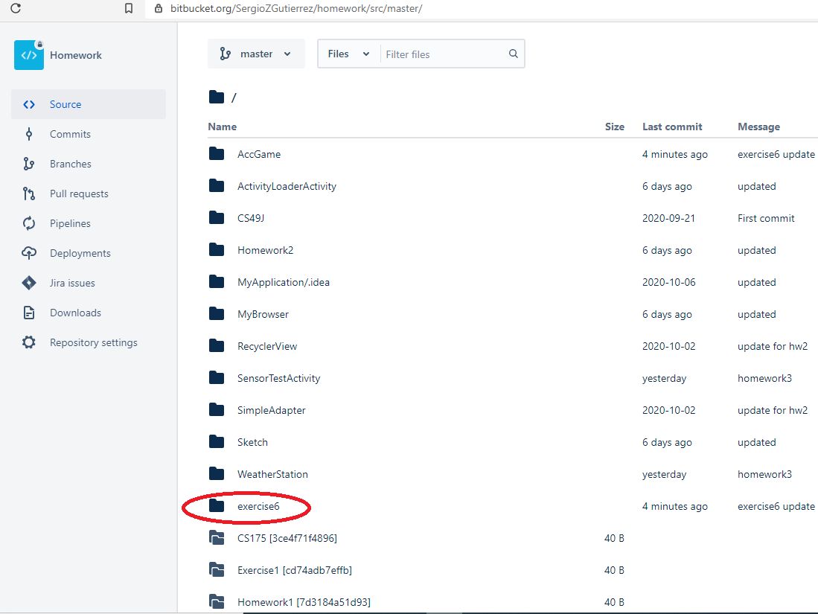

Exercise 6:

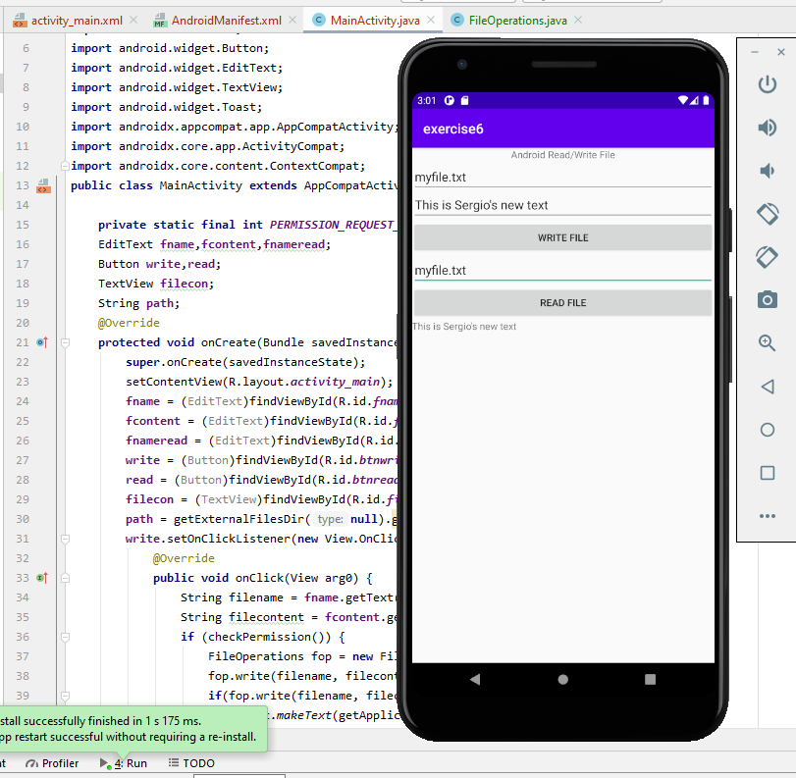:

The exact pathway of where the .java files are located in my repository is:

<https://bitbucket.org/SergioZGutierrez/homework/src/master/exercise6/app/src/main/java/edu/sjsu/android/externalstorage/>